Course Submission Checklist

1. Foundational Course Information
These details define the basic structure and audience of your course:
Course Type (Self-paced / Instructor-led)
Why: Helps learners know how the course will be delivered.
How: Choose one option based on your course format.
Course Title (max 10 words)
Why: A clear, concise title attracts learners.
How: Use keywords that reflect the content and purpose.
Type of Certification (Microcredential / Alliance4Life Certificate / None)
Why: Indicates if learners will receive formal recognition.
How: Select the appropriate certification type.
Please note: Courses with Microcredential require at least 25 hours of learner involvement.
Access to Course (Open Access / A4L members only / A4L members + strategic partners)
Why: Defines who can subscribe to the course.
How: Choose based on your intended audience.
Tip: Open-access courses are available to the largest audiences and maximize impact.

Target Audience (Researchers / Research Managers)
Why: Ensures the course meets the needs of the right group.
How: Specify the primary audience.
Competence Domain
Why: Aligns the course with recognized competency frameworks.
How: For research managers, select a domain from RMComp, For researchers, select a domain from ResearchComp.
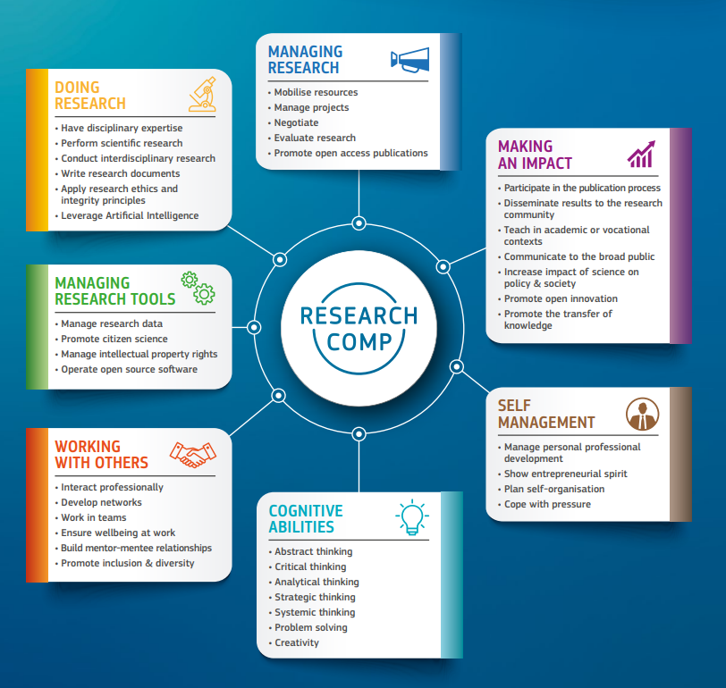
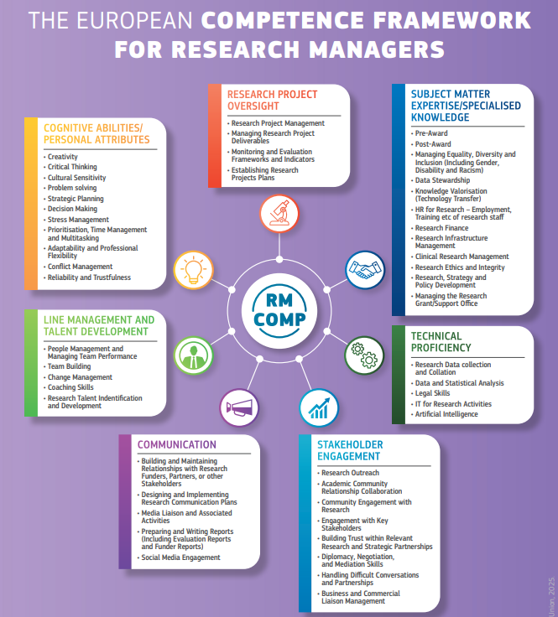
Competence Level (Foundational / Intermediate / Advanced / Expert)
Why: Indicates the complexity and depth of the course.
How: Choose the level that best matches your content.
Note: In both ResearchComp and RMComp, competence levels are defined by the degree of autonomy, complexity, and impact in applying a skill.
- Foundational: Basic understanding and ability to perform tasks under close guidance; limited responsibility.
- Intermediate: Can apply skills independently in familiar contexts; demonstrates problem-solving and adapts to routine challenges.
- Advanced: Handles complex tasks, provides guidance to others, and adapts methods to new situations; shows strategic thinking.
- Expert: Recognized authority in the field; innovates, sets standards, and influences policy or organizational practices.
If in doubt, refer to the Research Comp and RM Comp Framework on the Alliance4Life website
Estimated Workload (in hours)
Why: Helps learners plan their time.
How: Provide a realistic estimate based on course activities.

2. Course Details
These elements describe what the course offers and why it matters:
Short Course Description (up to 200 characters)
Why: Used for quick previews and listings.
How: Summarize the course in one sentence.
Example: “Learn to create clear, engaging scientific presentations tailored to diverse audiences, avoid common pitfalls, and boost your research visibility and impact.”
Long Course Description (150–200 words)
Why: Explains what the course covers, why it’s important, and its format.
How: Write a clear, engaging overview.
A short overview (100–200 words) that explains what the course is about, what topics will be covered, and why it’s relevant. It should be engaging and informative, giving potential learners a clear idea of what to expect.
Instructions for course creators: Write a concise summary of the course content. Focus on the main themes, the type of knowledge or skills learners will gain, and how the course can be applied in practice. This text will appear on the course landing page.
Example: "Giving scientific presentations is a vital skill for sharing research and gaining visibility in the wider scientific community. The ability to present clearly and confidently can greatly support career development—whether PhD students pursue academic research, move into industry, or start their own ventures. Yet many presentations fail to engage their audience, often due to common pitfalls such as overly complex content, lack of structure, monotonous delivery, or a mismatch between the speaker’s focus and the audience’s interests. This online course provides theoretical and practical foundation for creating effective scientific presentations. It is designed to help learners understand what makes a presentation impactful, how to tailor content to different audiences (scientific peers, potential funders, media, or the public), and how to structure and design their talk for maximum clarity and engagement.“
Learning Objectives (3–5 bullet points)
Why: Shows what learners will achieve.
How: Use action verbs and keep objectives specific.
A list of 3–5 specific, measurable goals that describe what learners will be able to know, do, or understand by the end of the course.

Example:
By the end of this course, learners will be able to:
- Describe the key principles of data management in Horizon Europe projects
- Apply best practices for grant proposal budgeting
- Identify common challenges in international collaboration
Completion & Certification Details (relevant only for yourses with certification)
Why: Tells learners what’s required to finish and earn a certificate.
How: Outline completion criteria and certification process.

Instructor Bio (3–4 sentences)
Why: Builds trust and credibility.
How: Highlight your expertise and relevant experience
Example: “Ester Jarour is an expert in science communication, dedicated to improving research visibility and public engagement. She has collaborated with the European Research Council (ERC) on initiatives such as the Science Journalism Initiative and served as an evaluator for the ERC Public Engagement Award. At CEITEC Masaryk University, she lectures the Science Communication course, highly valued by students for its practical approach. Ester also created the EU-LIFE Science Vision Talk Contest, inspiring researchers to communicate science through compelling storytelling.”

3. Organizational Details
These details help us schedule and manage your course.

Preferred Start Date
Why: Allows planning for publication and promotion.
How: Suggest a realistic date for launch.
Additional Note for E-learning Coordinator
Why: Share any special requirements or comments.
How: Add details that will help us support your course.

